**Download RazorSQL for Windows**

1. Navigate to <https://razorsql.com/download_win.html>
2. Chose 64 or 32 bit (Search 🡪 System to figure out yours)
3. Accept all agreements and install
4. Chose **Register Later:**

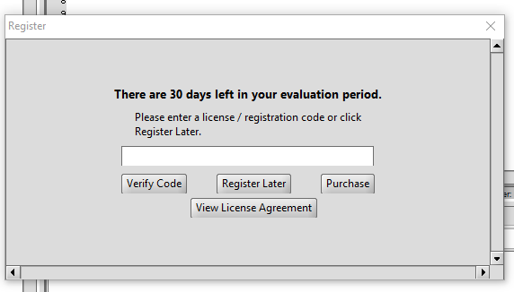

1. On the left chose **Click to Connect to Database** and choose **DynamoDB**

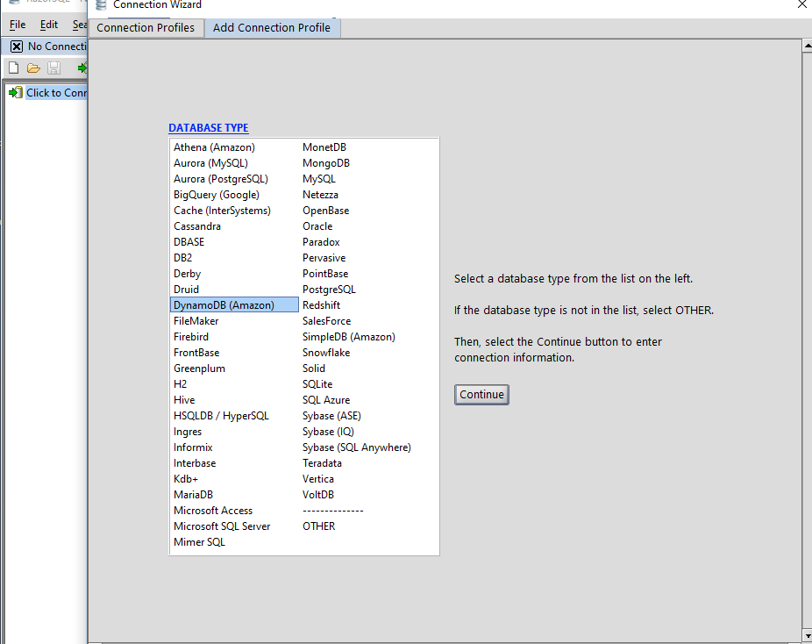

1. Chose **Profile Name** (whichever you like), **put AWS Access Key** and **AWS Secret Key** that you were emailed earlier, chose **Max Rows Per Query = 25** and leave everything else at default. Click **Connect.**

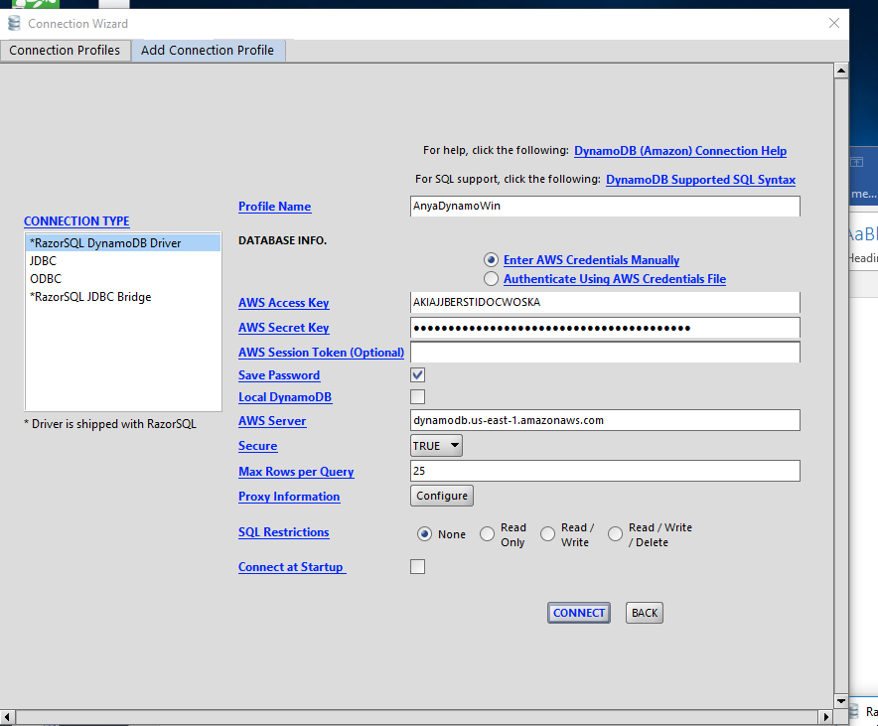

1. You should now see your tables

